NOTE: Please provide a screen shot of the outputs you get on your terminal.

- Give the output when the following sequence of commands is executed. If no output is displayed, write “blank” in the space provided.

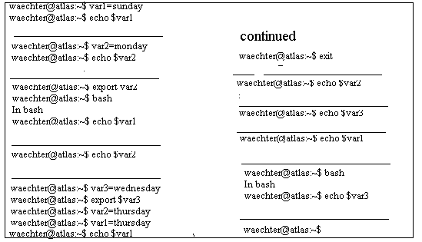

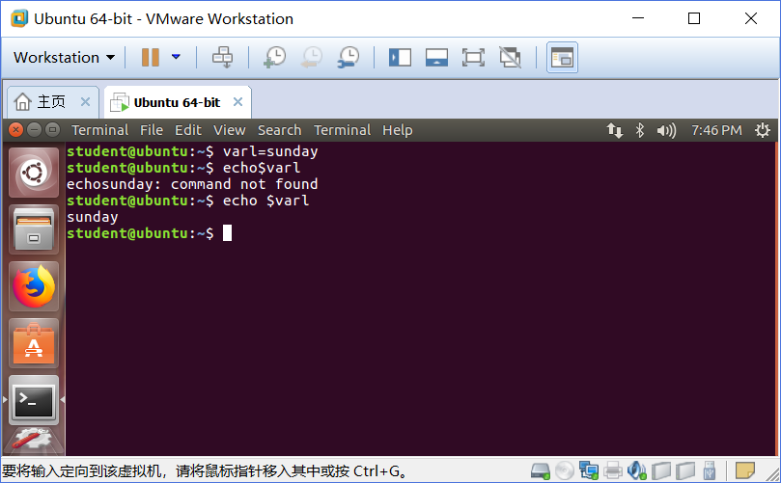
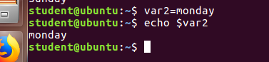

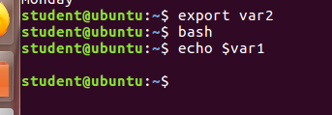

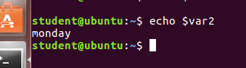

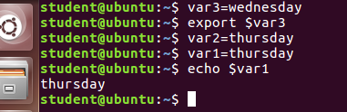





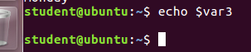





- In your home directory create files “f1.txt”, “f2.txt”, and “f3.txt” with the following content:

“f1.txt”  America is a great country.  LITTLE MARY  “f2.txt”  Little Mary | “f3.txt”  The American Revolution.  This is the best solution to the problem  PanAmerica Capital Group  the american people  ddd  United States of America  america  the brown fox jumped over a lazy dog.  Creative thinking
Write “grep” commands to accomplish the tasks listed below:

- List all the files in your home directory that contain the “little Mary” word phrase. Make the command case insensitive.
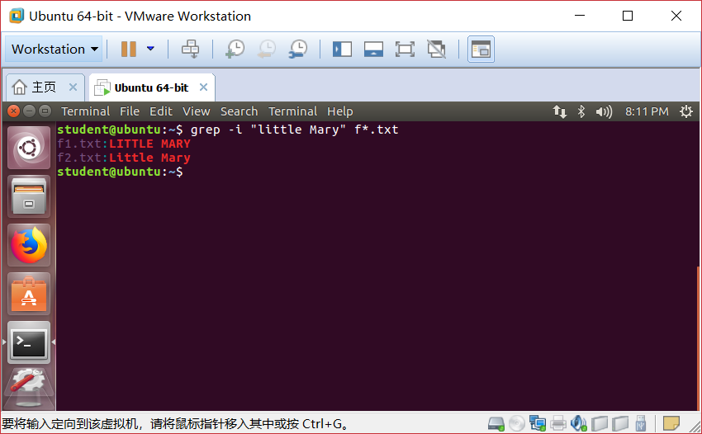
- List all the lines in the “f3.txt” file that contain words “America” or “america”. Please note that you are asked to search for words. Therefore, lines containing “American” or “PanAmerica” etc should not be listed.
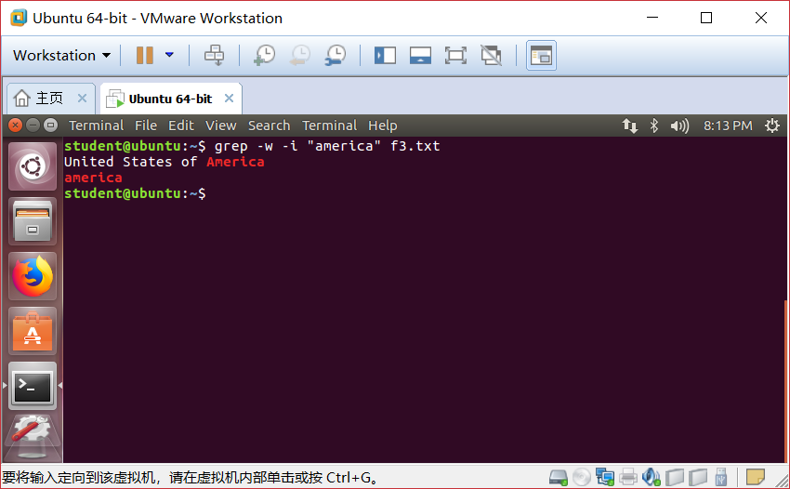

- List all the lines in the “f3.txt” file that begin with the words “The” or “the”.
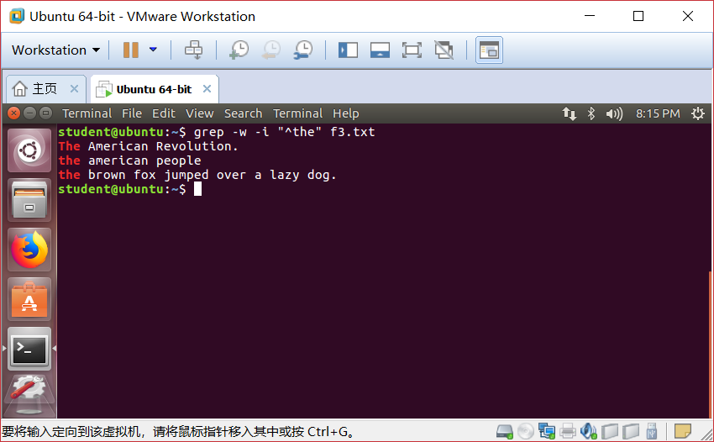
- List all the lines in the “f3.txt” file that end with a “.” character.
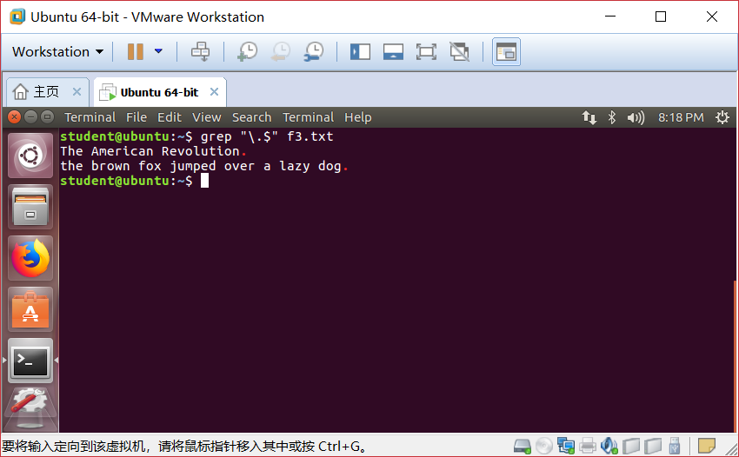

- List all the lines in the “f3.txt” file that begin with either “The” or “the” and end with a “.” Character.
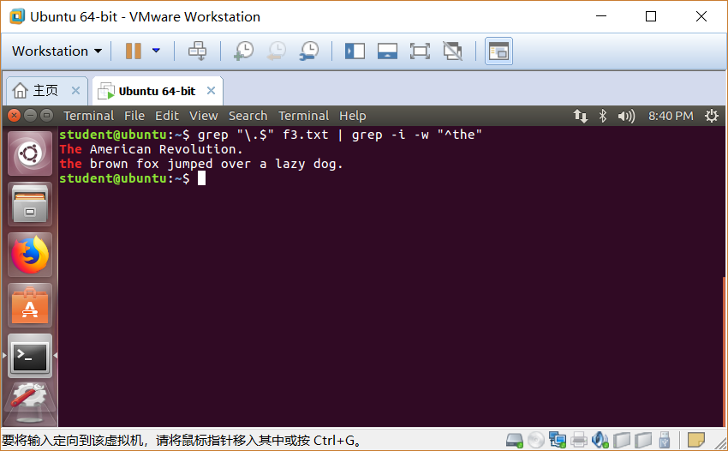
- List all the lines in the “f3.txt” file that contain words which contain exactly one vowel.
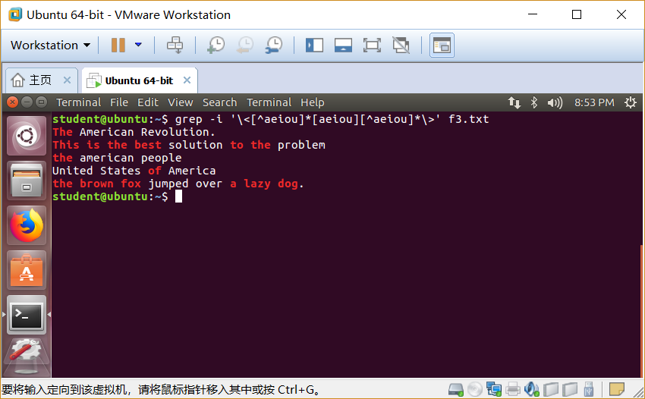
- List all the lines in the “f3.txt” file that contain words with a character ‘b’ not followed by a character ‘e’.

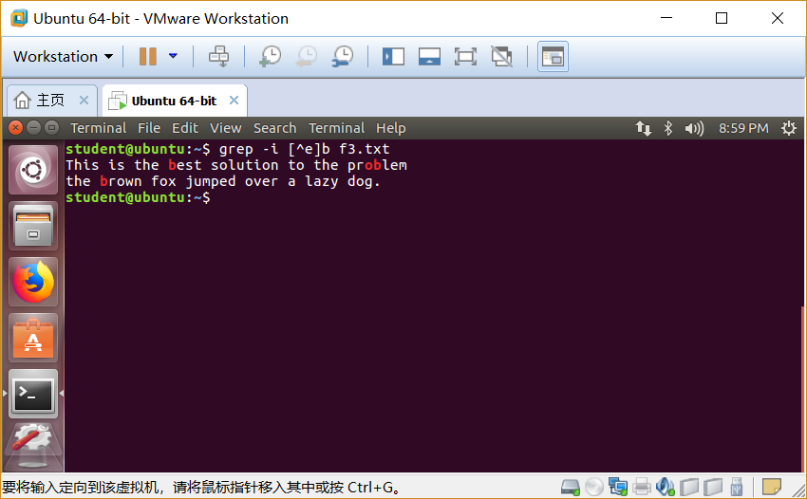

- List all the lines in the “f3.txt” file that contain the words which contain no vowels.

